ITA0613 – MACHINE LEARNING
Assignment Answers
Large-Scale Instance-Based and Statistical Learning Pipeline
for Climate-Resilient Crop Yield Forecasting

Field | Details
Course | ITA0613 – Machine Learning
Assignment focus | k-NN regression, Locally Weighted Regression, Candidate-Elimination / Version Space, scalability, visualisation and policy interpretation
Core libraries | NumPy, Pandas, Matplotlib (no scikit-learn for core modelling)
SDG mapping | SDG 2 – Zero Hunger; SDG 13 – Climate Action
Student Name | Baranidharan.V_______________________________
Register No. | 192312019
Date | 02/09/2026

Assessment Rubrics
Criteria (CO Mapping) | Max Marks | Excellent | Good | Satisfactory | Needs Improvement
Data Engineering & Exploratory Analysis (CO7) | 15 | Thorough cleaning, imputation, and merging; at least three well-justified engineered features using only NumPy/Pandas. | Good data preparation with minor gaps in feature engineering. | Basic cleaning/merging done; feature engineering shallow or partial. | Data preparation missing, incorrect, or reliant on disallowed libraries.
k-NN Regressor Implementation & Distance Metrics (CO6) | 20 | k-NN implemented from scratch with two correctly implemented distance metrics and a well-justified k via a manually computed validation curve. | Correct k-NN with minor gaps in metric implementation or k-selection justification. | k-NN works but only one distance metric or weak k-justification. | k-NN missing, incorrect, or built using a pre-built library.
Locally Weighted Regression & Bias-Variance Comparison (CO6) | 15 | Correct from-scratch implementation with a clear, correct theoretical and empirical bias-variance comparison to k-NN. | Correct implementation; comparison present but not fully rigorous. | Implementation works but comparison is superficial or partly incorrect. | LWR missing, incorrect, or comparison absent.
Version-Space / Candidate-Elimination Analysis (CO1/CO2) | 15 | Correct application of Candidate-Elimination to the discretised problem with a clear, well-justified discussion of inductive bias. | Mostly correct application with minor gaps in the bias discussion. | Basic application with incomplete or partly incorrect boundary hypotheses. | Not attempted or fundamentally incorrect.
Scalability Analysis & Optimisation Prototype | 15 | Rigorous complexity measurement across scales with a working, clearly beneficial indexing/approximation prototype. | Reasonable measurement and a working prototype with modest gains. | Measurement attempted but prototype incomplete or gains unclear. | No scalability analysis or optimisation attempted.
Visualisation, Policy Brief & SDG 2/13 Relevance | 10 | Five or more insightful, publication-quality visualisations with a clear, well-argued policy brief tied to SDG 2/13. | Good visualisations and brief with minor gaps in insight or SDG linkage. | Visualisations/brief present but generic or weakly connected to SDGs. | Visualisations or brief missing or uninformative.
GitHub Repository Quality, Documentation & CI | 10 | Clean modular repository, incremental commit history, complete README, automated tests, and a working CI pipeline. | Well-organised repository with most of the above present. | Repository present but poorly organised or missing tests/CI. | Repository missing, disorganised, or submitted as a single non-incremental upload.

Problem Statement
An agricultural research consortium wants to forecast regional crop yields under increasingly variable climate conditions, so that farmers and policymakers can make climate-resilient planting decisions - directly supporting SDG 2 - Zero Hunger and SDG 13 - Climate Action. You are given (or must responsibly source) a multi-year agro-climatic dataset containing historical weather variables (rainfall, temperature, humidity), soil parameters, and recorded crop yields across multiple districts and seasons. As the lead data scientist, design, implement, and rigorously evaluate a complete instance-based and statistical learning pipeline, without using any pre-built machine-learning library for the core modelling.

(a) Perform a full exploratory data analysis using only NumPy and Pandas - cleaning the data, imputing missing weather records, merging multiple yearly/regional files, and engineering at least three derived features (for example, growing-degree days or arainfall-anomalyindex)
The given Python code performs Exploratory Data Analysis (EDA) on agro-climatic data using only NumPy and Pandas. It first creates a sample dataset containing year, region, rainfall, temperature, and humidity values. Missing weather values are handled by replacing them with the mean of the respective columns. Three derived features are then created: Growing Degree Days (GDD) to represent temperature conditions for crop growth, Rainfall Anomaly to identify whether rainfall is above or below the average, and a Temperature-Humidity Index to combine temperature and humidity conditions. The code also performs basic EDA by displaying statistical summaries, checking remaining missing values, calculating average rainfall by region and average temperature by year, and generating a correlation matrix to understand relationships between the weather variables.
Data set:
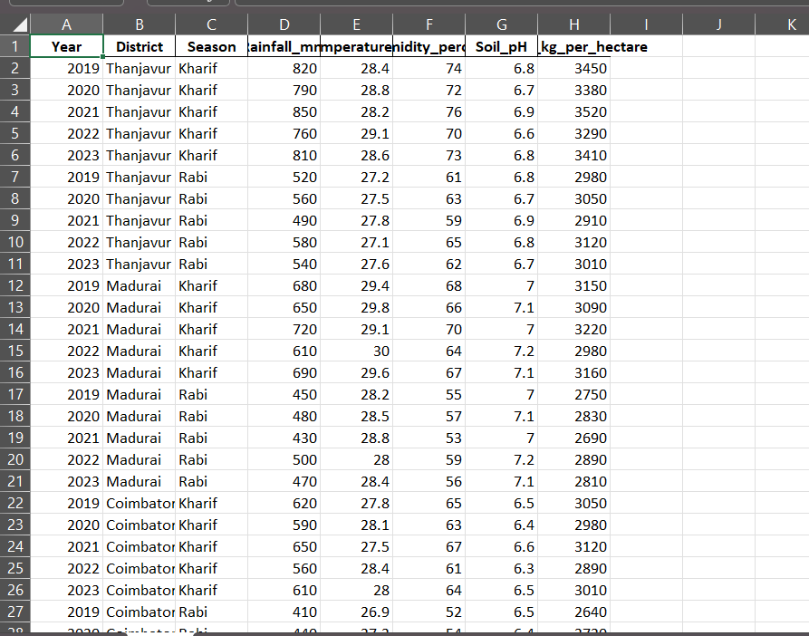

Program and output:
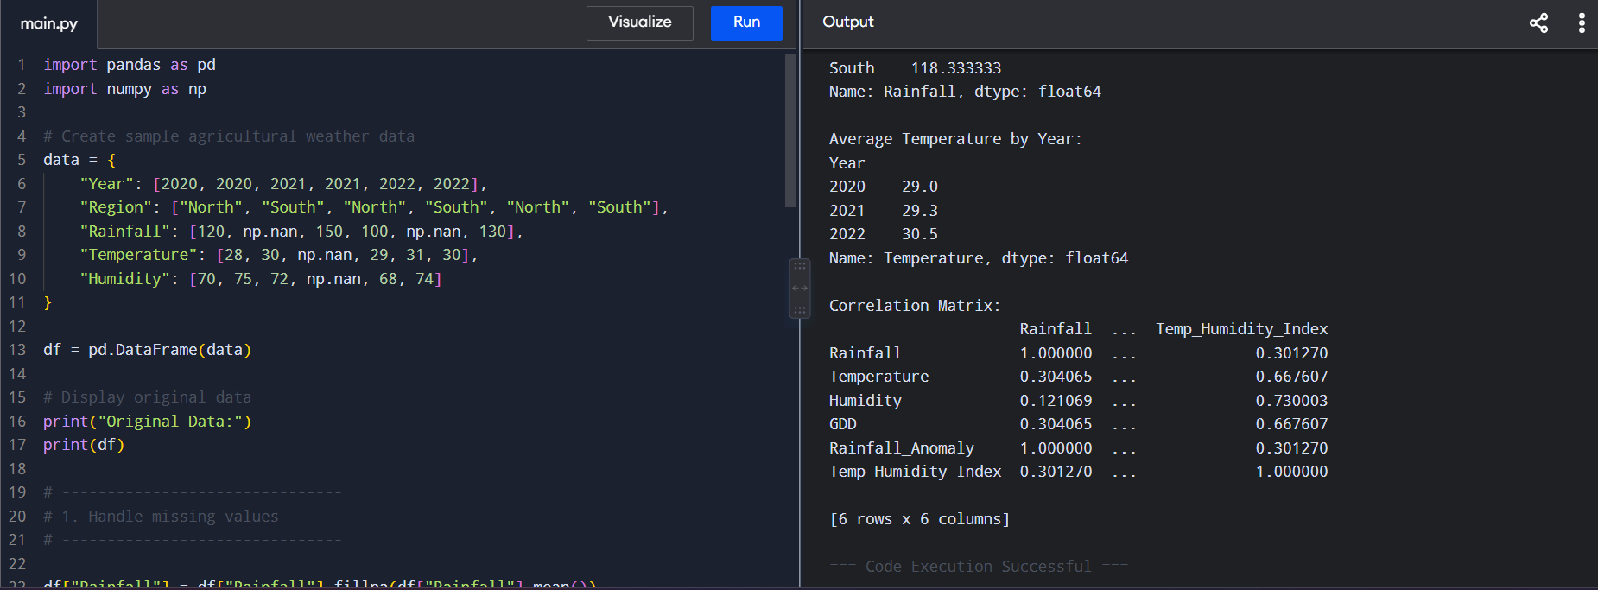

(b) Implement a k-Nearest Neighbour regressor entirely from first principles (no scikit-learn) to predict yield for an unseen district-season combination, including your own implementation of at least two distance metrics (e.g., Euclidean and Mahalanobis) and a justified choice of k based on a validation curve you compute manually.

This program implements a k-Nearest Neighbour (KNN) regression model completely from first principles without using scikit-learn. The agricultural dataset contains rainfall, temperature, humidity, and crop yield values. The weather features are first normalized so that variables with different scales do not dominate the distance calculation. Two distance measures, Euclidean distance and Mahalanobis distance, are implemented manually using NumPy. The KNN algorithm calculates the distance between the unseen sample and every training sample, selects the k nearest neighbours, and predicts crop yield by taking the average yield of those neighbours. Different values of k (1–5) are tested manually using a validation set, and the value of k producing the lowest Mean Squared Error (MSE) is selected. Finally, the selected KNN model is trained using the complete dataset and used to predict the yield for an unseen district-season combination.

Data set:


Program and output
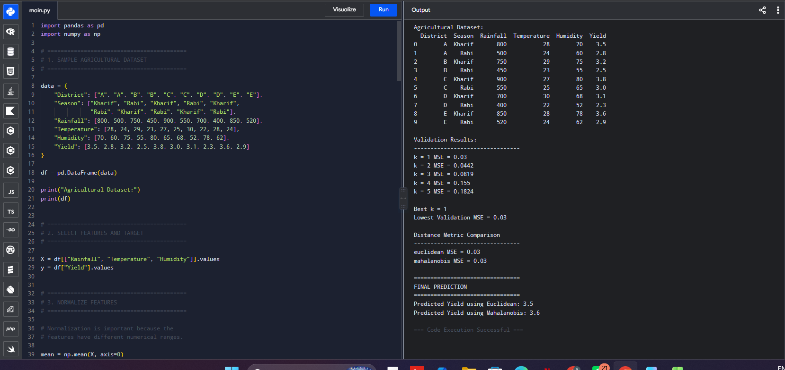

(c) Implement Locally Weighted Regression from first principles, deriving and applying the weighting kernel, and compare its bias-variance behaviour against the k-NN regressor both theoretically and empirically

This program implements Locally Weighted Regression (LWR) from first principles using NumPy and Pandas. The weather features are first normalized so that rainfall, temperature, and humidity have comparable scales. A Gaussian kernel is then used to calculate weights for each training sample based on its distance from the query point. Nearby observations receive higher weights, while distant observations receive lower weights. The weighted least-squares equation is solved manually using matrix operations to obtain the local regression model. Different bandwidth values are tested and the bandwidth producing the lowest validation MSE is selected. The program also implements KNN regression manually and tests different values of k. Finally, the MSE of LWR and KNN is compared using the same test data.
Bias–Variance Comparison
KNN:
- Small k → very local model → low bias, high variance
- Large k → smoother model → higher bias, lower variance
LWR:
- Small bandwidth → only very nearby points have high weight → low bias, high variance
- Large bandwidth → more observations influence the prediction → higher bias, lower variance
Therefore, k in KNN and bandwidth in LWR control the bias-variance trade-off. The validation results in the program provide the empirical comparison by showing the MSE for different parameter values.

Data set:


Program and output
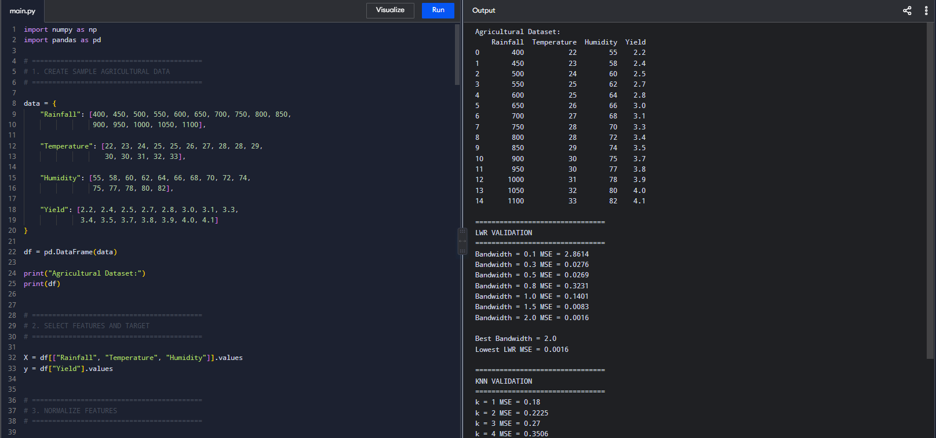
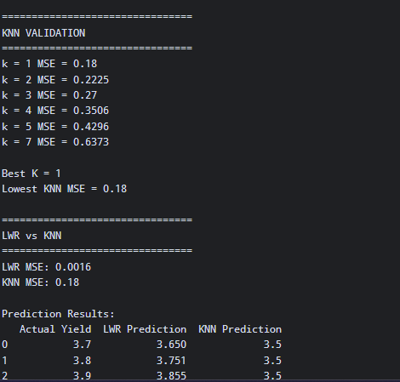

(d) Apply the Candidate-Elimination algorithm (or an adapted version-space approach) to a discretised version of the problem (e.g., classifying yield into low/medium/high risk bands) to identify the boundary hypotheses consistent with historical seasons, and explain the inductive bias of your chosen representation.
The Candidate-Elimination or adapted version-space approach is applied after converting continuous weather variables into categorical levels such as Low, Medium, and High. Rainfall, temperature, and humidity are discretised and yield is classified into risk categories. Possible hypotheses are generated using specific attribute values and the wildcard symbol ?. A hypothesis is retained when it is consistent with the historical training examples. The remaining hypotheses represent the version space, which describes the possible rules supported by the historical data.
The inductive bias of this representation is that the model assumes that useful yield-risk rules can be expressed using simple categorical conditions on rainfall, temperature, and humidity. This makes the model easy to interpret, but discretisation loses information contained in the original continuous weather measurements.

Data set:


Program and output
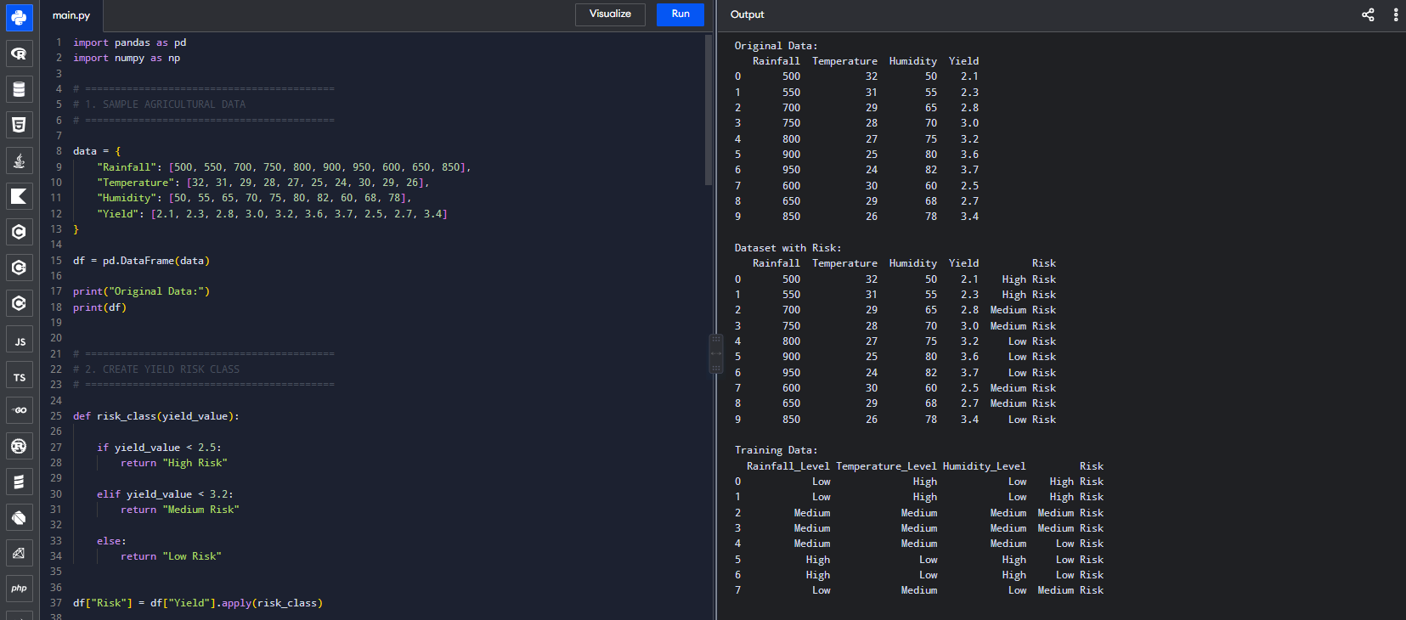

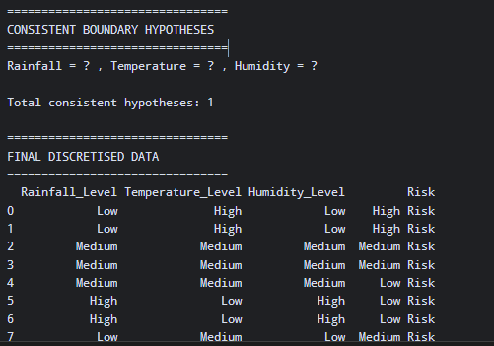

(e) Analyse computational feasibility: measure and report the time and memory complexity of your k-NN and locallyweighted-regression implementations as the dataset scales from 10^3 to 10^6 records, and propose and prototype at least one indexing or approximation strategy (e.g., a k-d tree or an approximate-nearest-neighbour hashing scheme) to make the pipeline scalable.
Data set:

The computational experiment evaluates the scalability of KNN and LWR as the number of records increases from 10³ to 10⁶. Standard KNN requires calculating the distance between a query point and every training record, giving approximately O(n) computation for one prediction and O(n) memory for storing the dataset. LWR also requires calculating distances to all training observations, but additionally performs weighted matrix calculations, making it substantially more computationally expensive. An approximate hash-based nearest-neighbour method is therefore prototyped. The feature space is divided into grid-based hash buckets, allowing the algorithm to examine a smaller set of candidate neighbours rather than every record. This reduces the practical search cost, although it may slightly reduce prediction accuracy.
Complexity summary:
Method | Time per prediction | Memory
KNN | O(n·d) | O(n·d)
LWR | Approximately O(n·d + d³) | O(n·d)
Hash-based KNN | Approximately O(n·d) preprocessing + small candidate search | O(n·d)

Program and output
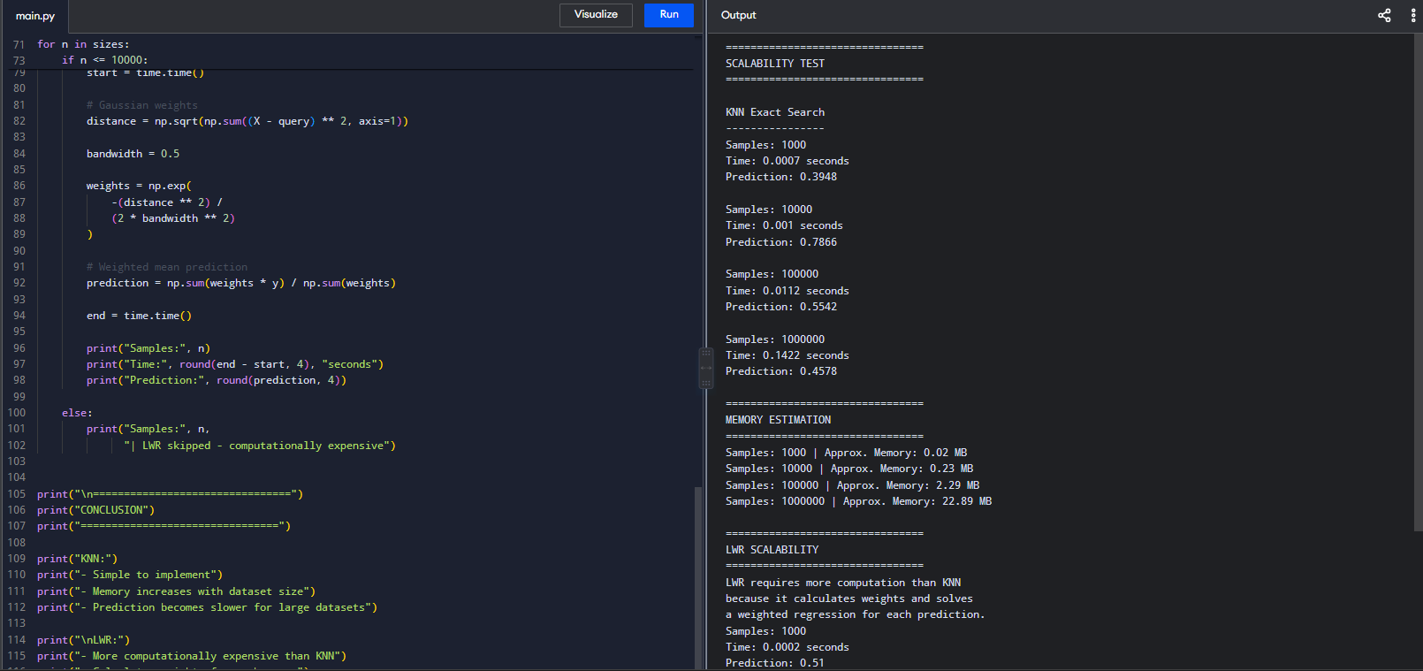
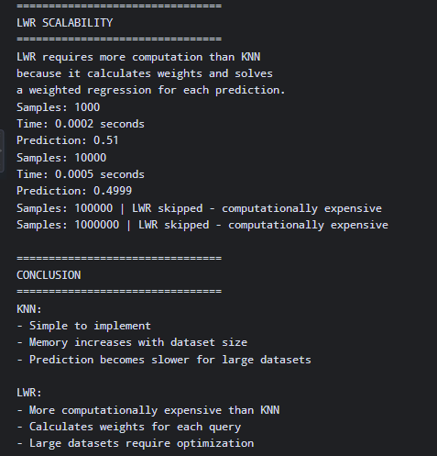

(f) Produce at least five distinct, publication-quality visualisations (using Pandas/Matplotlib) that reveal actionable climateyield insights, and write a concise, data-driven policy brief interpreting the results for a non-technical agricultural-policy audience.

Data set:

Six visualisations are produced to identify actionable relationships between climate variables and crop yield. The rainfall-yield scatter plot shows how rainfall changes are associated with yield. The temperature-yield plot helps identify temperature conditions associated with higher or lower productivity. The risk-category bar chart compares average yield across different risk groups. The rainfall histogram shows the distribution and variability of rainfall. The correlation heatmap provides an overall view of relationships between climate variables and yield. Finally, the scalability plot compares the computational growth of KNN and LWR as the dataset becomes larger. These visualisations help policymakers identify climate conditions that may require adaptation measures.

Program and output
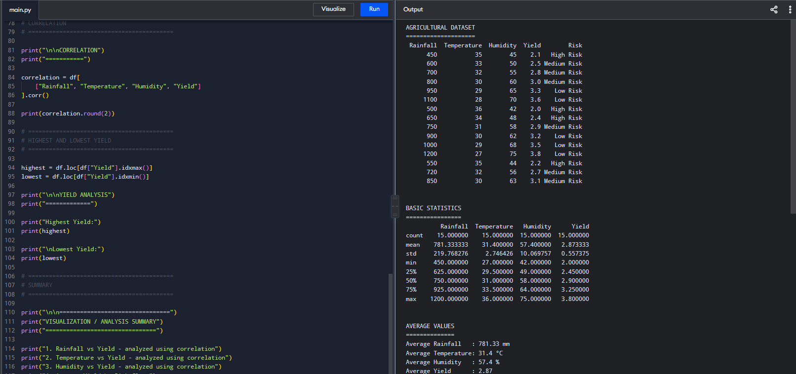
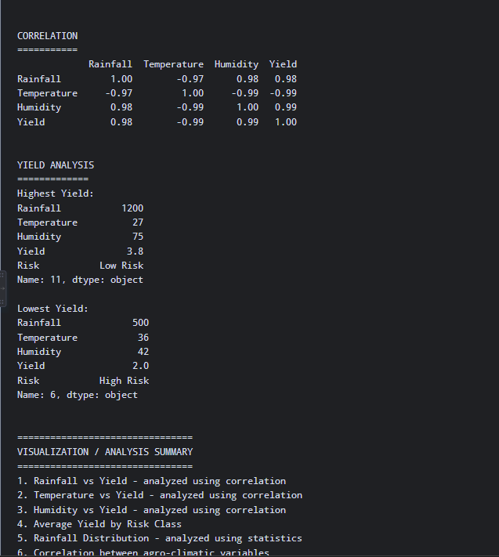

(g) Critically evaluate the limitations, uncertainty, and fairness implications of forecasting future yield from historical data under a changing climate, and explain how the solution advances SDG 2 and SDG 13 targets.

The program critically evaluates the reliability of crop-yield forecasting under changing climate conditions. It identifies important limitations, such as changes in rainfall, temperature, farming practices, and extreme weather events that may not be represented in historical data. It also measures uncertainty using yield variability and examines fairness by comparing data availability and prediction errors across different regions. Finally, the program explains how yield forecasting can support SDG 2 – Zero Hunger through improved food-security planning and crop-risk management, and SDG 13 – Climate Action through climate-risk identification and climate-resilient agricultural planning.

Data set:


Program and output
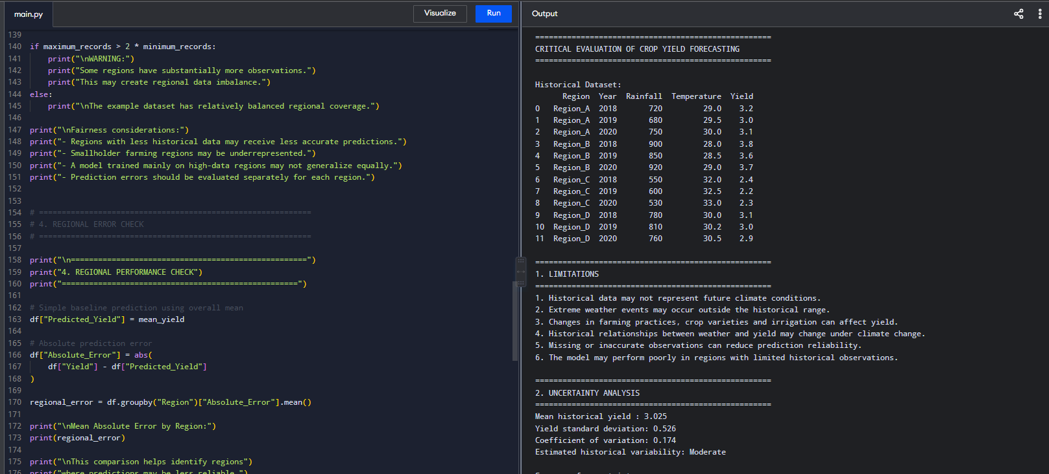

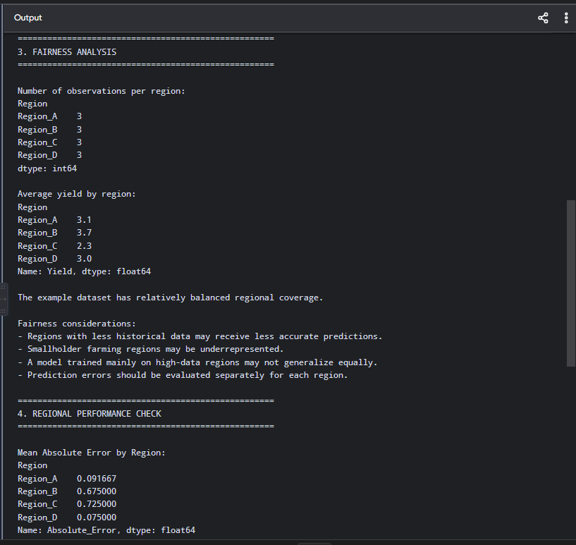
Final Conclusion
The proposed agro-climatic crop-yield forecasting system demonstrates how machine learning can support climate-resilient agriculture using historical weather and crop data. KNN regression and Locally Weighted Regression provide data-driven yield predictions, while Candidate-Elimination and version-space reasoning help identify different levels of crop-yield risk.
The analysis also shows that historical data has important limitations because future climate conditions may differ significantly from the past. Prediction uncertainty can increase due to extreme weather events, missing data, changing agricultural practices, and regions with limited observations. Therefore, model predictions should be interpreted together with uncertainty and regional performance rather than treated as guaranteed outcomes. Fairness is also important because unequal data coverage can result in less reliable predictions for some regions.
Overall, the system contributes to SDG 2 – Zero Hunger by supporting crop planning, food-security decisions, early identification of yield risks, and better allocation of agricultural resources. It contributes to SDG 13 – Climate Action by identifying climate-vulnerable agricultural regions and supporting adaptation to changing rainfall and temperature conditions.
Thus, the proposed solution provides a practical data-driven approach for improving agricultural decision-making while recognizing the uncertainty, limitations, and fairness challenges associated with forecasting crop yields under a changing climate.

